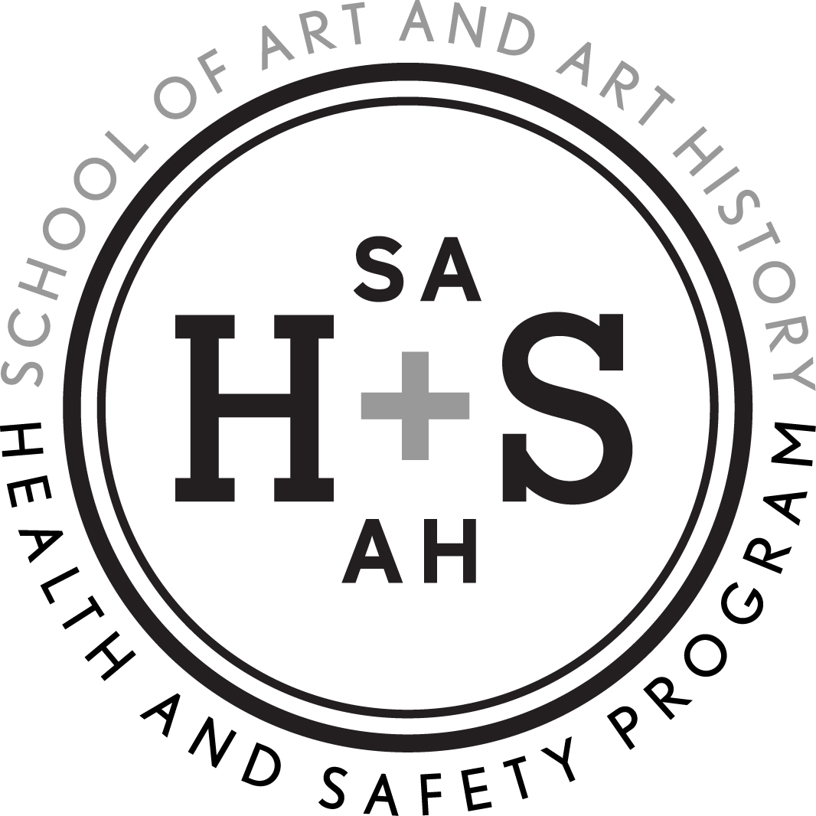 | SA+AH Health and Safety Program  STUDENT SIGNATURE PAGE

To be filed in the SA+AH Director of Operations Office, FAC 103 no later than the third course meeting date.

Course Title

Instructor

Meeting Room

Semester/Year

My instructor has reviewed the policies (pg. 1-15) in the School of Art + Art History Health and Safety Handbook with me as well as the inherent hazards of my course media, best practices, links to more information and the area rules. I understand that I am responsible for the information within.

A copy of the handbook may be found on the School of Art + Art History website: www.arts.ufl.edu/art/healthandsafety

Student Name (printed clearly) | Student Signature

